# PF LAB 12

NAME :Mehreen Fatima

SAP ID: 63255

# TASK 1:

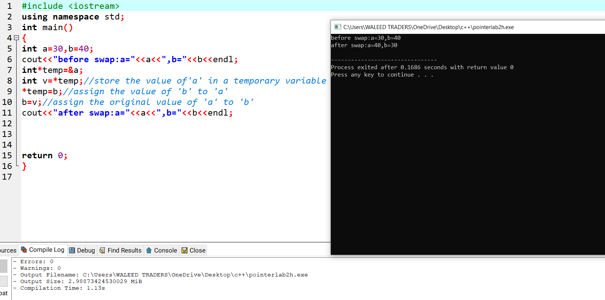

# TASK 2:

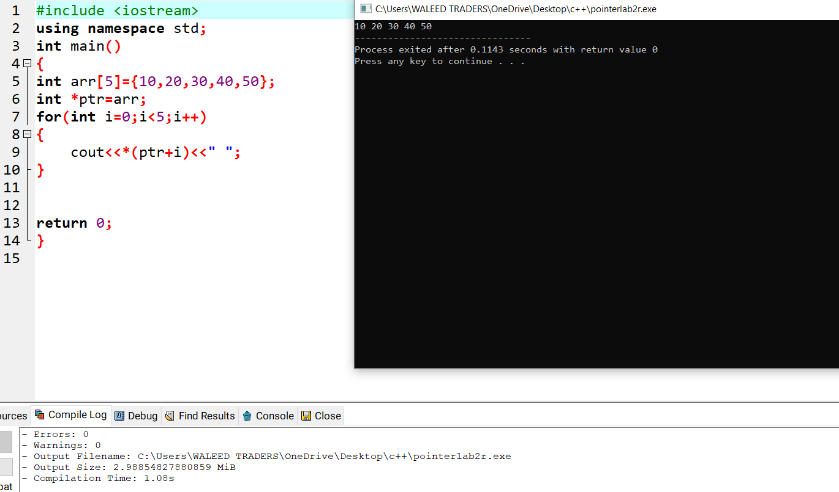

# TASK 3:

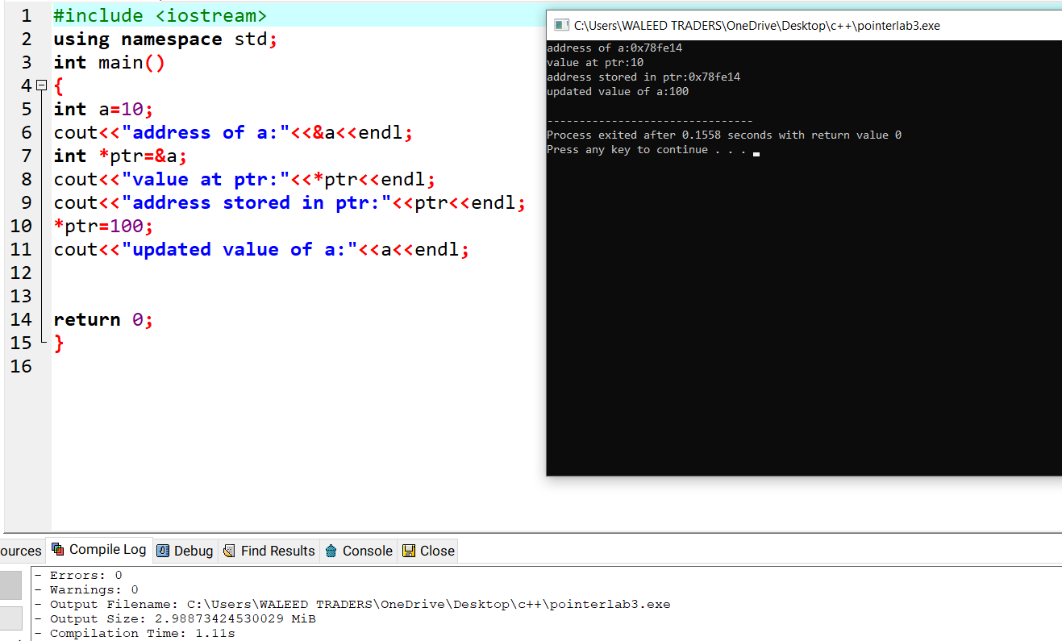

# TASK 4:



